Tensor Flow 2.0
Anaconda Prompt Install Tensor Flow 2.0
pip install tensorflow-gpu==2.0.0-alpha0

Use the following command to check CUDA installation by Conda:
conda list cudatoolkit

And the following command to check CUDNN version installed by conda:

conda list cudnn

If you want to install/update CUDA and CUDNN through CONDA, please use the following commands:
conda install -c anaconda cudatoolkit

List all environments

conda env list

Remove Environments

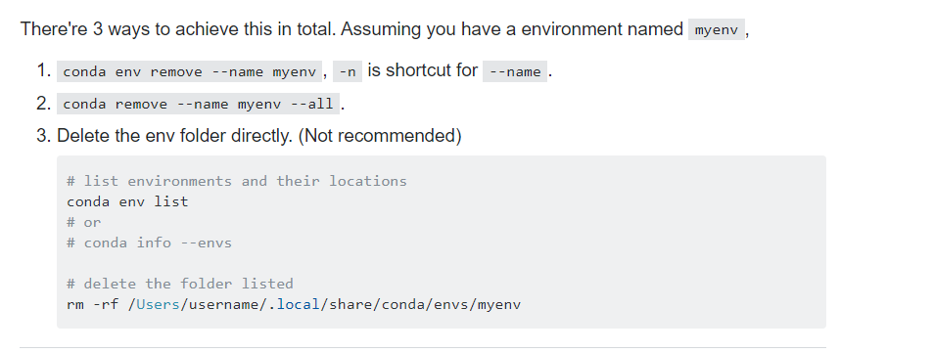

CPU (central processing unit) A GPU (graphics processing unit)

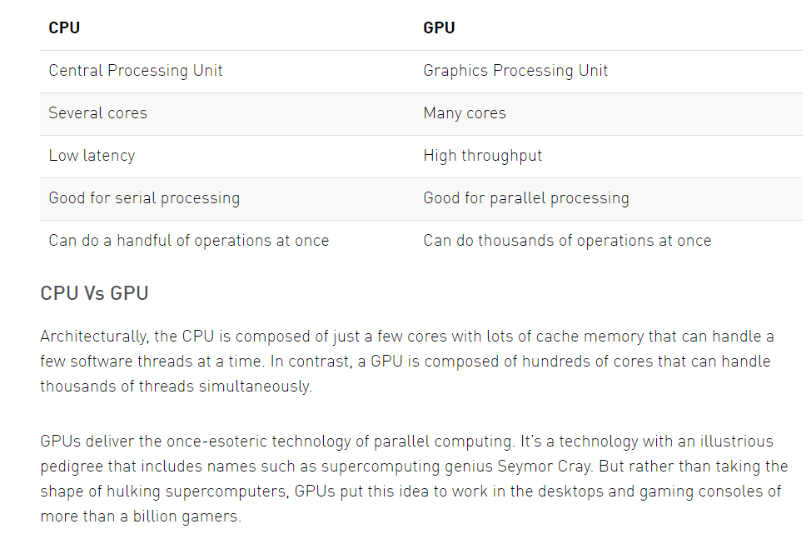

Check Version of Tensor Flow

import tensorflow as tf

tf.__version__

Create a constant (Scalar)( Constant Function)
tensor1 = tf.constant(20)
print (type(tensor1))

print (tensor1)

Create a Constant (Matrix )
tensor_20 = tf.constant([[23, 4], [32, 51]])
tensor_20

Shape of a Tensor
tensor_20.shape

Data Type of Tensor Element
tensor_20. dtype

Getting the values from a TensorFlow constant with numpy, and without session
tensor_20.numpy()

Convert a numpy array back to a TensorFlow tensor as well
Create Array

import numpy as np
numpy_arr1 = np.array([[23, 4], [32, 51]])
print (numpy_arr1)
Convert Array to Tensor

tensor_arr = tf.constant(numpy_arr1)
print (tensor_arr)

Variables (Variable Class)

Defining Variables

tf2_variable = tf.Variable([[1., 2., 3.], [4., 5., 6.]])
tf2_variable

Print Variable
print (tf2_variable)

Get Values from Variable
tf2_variable.numpy()

Changing/ updating a specific value in the variable

tf2_variable [0, 2].assign(100)

print (tf2_variable)

Operations with Tensors
Create Constant
tensor = tf.constant([[1, 2], [3, 4]])
tensor

Add scalar and a tensor
print (tensor + 2)

Multiplication between a scalar and a tensor
t1 = tensor * 5
print (t1)

Numpy functions on TensorFlow tensors

squares
np.square(tensor)

square root
np.sqrt(tensor)

Multiply between two tensors

tf1 = tf.Variable([[1., 2., 3.], [4., 5., 6.]])
tf2 = tf.Variable([[2., 3,4], [5,6,7]])
tf3 = np.dot(tf1,tf2)

print ('TF 1\n',tf1.numpy(),'\n')
print ('TF 2\n',tf2.numpy(),'\n')
print ('TF 3\n',tf3.numpy(),'\n')

String Operations
tf_string = tf.constant("TensorFlow")

print (tf_string ,'\n')

print (tf_string.numpy())

Length of a string
print (tf.strings.length(tf_string),'\n')

print (tf.strings.length(tf_string).numpy())

Unicode of a string
tf.strings.unicode_decode(tf_string, "UTF8")

Storing Arrays of strings

tf_string_array = tf.constant(["TensorFlow", "Deep Learning", "AI"])

for string in tf_string_array:
print(string)
print(string.numpy(),'\n')

